Project based learning in the first and second 3-year period of nine-year primary school products of Das mass material - “From idea to creation”

Petra Bukovec, Prof., Primary School Grm, Novo mesto, Slovenia, Assist. Prof. Ddr. Jožica Bezjak, Faculty of Education, University of Ljubljana, Slovenia

abstract

The project “Project based learning in the first and second 3-year period of nine-year primary school - products of Das mass material” was carried out as part of school technical days that are a part of regular education in the nine-year primary school.All sorts of planning (content as well as operative planning) and its performance and presetation of final projects are described. The project covers twenty products, suitable for the development of pupils´ creativity. Pupils learn how to use technics and technology in their every day life and how to apply various technical tools and materials. They learn about different ways of technology used in such working process.This project based learning is aimed at presenting the variety of products made of DAS mass. Simultaneously, such learning promotes the development of technical creativity, it enhances self-reliance and satisfaction with the results of one´s endeavour.

Key Words : project based learning, project development, technical days, das mass, elaboration and use of das mass products, tools and instruments, different sorts of materials.

argumentation of the project
With this project I want to introduce pupils to the handmade products from das mass. I have concentrated on the useful products. At working with das mass one has a lot of various possibilities. One can not only work with das mass, but also combine it with other materials such as glass, metal, wood, ceramics ... Throughout the project the pupils learn to respect the work. With self-success and empiric learning their contentment, self-confidence and positive self-esteem grows. With making the more complex or demanding products the pupils develope hand skills, coordination of hands and eyes, patience and endurance.das mass is easy to knead and it can also be softened with water, so it is also suitable for younger children. It does not demand special storing and can be easily washed off hands. Due to this good qualities it has a great value and it can be highly recomended for use in schools.Because of its correspondence with the suggested contents, the theme Products of das mass can be well included in the technical days in the nine-year primary school. This theme also enables cross-curriculum connection.

concept of the project
One ussually sends a greeting card to friends and relatives at their personal and other festivals. It is common to also give them a present besides best wishes and thoughts. Sometimes one do not know what to give, so he often buys some useless gift. On the contrary he can give a valuable unique product made of das mass. This kind of gift has a value and meaning. It is made with the thought of the person who will get it. The decorations, colour and shape are chosen to suit the one celebrating. In this way one can do a really usefull product. The value of the product will be greater if it is made by a child, who involves in it his effort and imagination. He can also write a wish on the back side of it.In school the teacher stimulates the pupils to make the product and motivates them to create for themselves at home, even to head for creative proffesions.

macro preparation of the project
The pupils together with the teacher decide and plan the sketch of the project work that will help them to realize the project. Along the sketching the pupils settle (among themselves) what kind of products they will make, they exchange their thoughts and ideas. They make the sketch with clearly fixed strategy on the poster.

THE PRODUCTS OF DAS MASS

WHAT DO WE WANT TO FIND OUT?
WHAT DO WE KNOW?

- the characteristics of das mass
- how to make the products from das mass
- what are the degrees of elaboration
- what do we need for elaboration

- The products are usefull
- The products are unique

WHAT WE WILL DO?
- we will make a product from das mass
- we will visit a potter
- we will use the product
- we will prepare an exhibition of the products

MICRO PREPARATION OF THE PROJECT
 | 1st partial activity | 2nd partial activity | 3rd partial activity
 | A VISIT OF A POTTER | ELABORATION OF THE PRODUCT FROM DAS MASS | EXHIBITION OF THE PRODUCTS
what? | - observation of the maker at work  - finding out whether the procedures are amending  - establishing the differences between clay and das mass | - collecting material for elaboration  - kneading, gluing, cutting out and impressing the material  - surface work (dyeing, varnishing and decorating a product) | - arranging the room  - colecting and placing the products  - evaluation of the products made from das mass  - invitation to exhibition  - guiding visitors on the exhibition
how? | - by listening  - with observing  - with self-research | - with own work  - with teacher’s help  - with other pupils’ help  - with own creativity  - with precision and patience  - with collaboration | - with one’s own work  - with demonstration  - with creativity  - with guiding an exhibition
where? | - in pottery workshop | - in art classroom | - in art classroom  - in a school hall  - in a corridor  - in a gym
when? | - at technical day  - during art lesson  - during “spoznavanje okolja” | - technical day | - day of open doors  - technical day
who? | - pupils  - a primary teacher  - an art teacher | - pupils  - a primary teacher  - an art teacher | - pupils  - a primary teacher  - an art teacher  - parents and visitors of the exhibition
with wat? | - with suitable behaviour  - with theme complex at “spoznavanje okolja” | - with das mass and other different material  - with different tools, rolling-pin, glue, oil colours | - with pupils’ products  - with posters  - with photographs  - with video clips
why? | - to get to know the traditional craft  - to aquaint them with this way of creating  - to recognize the meaning of making (elaborating) the products  - to make a product | - to develope one’s own imagination and creativity  - to develope one’s hans skills  - to stimulate an interest for creating  - to develope a product | - to show other pupils, teachers, parents and other visitors of exhibition what they have elaborated

REALIZATION OF THE PROJECT
Project technical days demand profound preparation. All pupils have to be involved in the work and the teacher has to motivate them to make original and imaginative products. Pupils are present at all working stages of the project.The teacher as na initiator of this project has to present the project to the pupils. He has to explain to pupils what project based learning is, what are its characteristics, stages and peculiarities, for this is a new kind of work for them.The pupils devide into groups according to their interest. The teacher can suggest them what kind of product they could make, but it is better when they decide for themselves, for they know best what their wishes and abilities are. The teacher’s role in the elaboration is that he stimulates the pupils and directs them to help eachother and to exchange their ideas.The required material and tools are placed on the beforehand appointed place. The pupils have to be warned to put all spare material and tools on this place.The activities can be planned for individual day or the work can be organised so that the project continues after certain time interval at the next technical day. At planning the technical day the contents should be connected with other subject areas. Beside that it is neccessary to assure all safety precautions.

Technology of elaboration: THE TREE

1st stage |  |  | 5th stage
Knead the das mass well, so it becomes soft. | 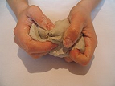 |  | Colour the bigger balls with different shades of green oil paint and the smaller ones with red oil paint. | 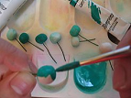
2nd stage |  |  | 6th stage
Give the das mass into a beforehand prepared bowl and smooth it with water. Glue a styrofoam ball on a stick, then press the stick into the das mass. | 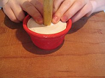 |  | Varnish all the balls with lac on water basis.  Wait for them to dry. | 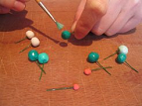
3rd stage |  |  | 7th stage
Use therest of the das mass to make a bunch of balls the same size for the top of the tree. Then make around 15 small balls to represent the cherries. | 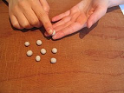 |  | Press the balls on wire into the big styrofoam ball. Place the balls in a way that the same shades of green are not together. When the top of the tree is made, press in the cherries – small res balls. | 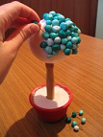
4th stage |  |  | 8th stage
Put the balls on the wire and make a snare at the end of it. Left overnight for the das mass to dry. | 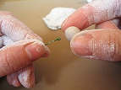 |  | Press some glue from the glue-gun on the dried das mass and sprinkle fine sand on it.  For decoration tie a red mesh on the stem. | 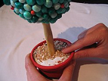

finished products:
  Picture1: A christmas decoration | 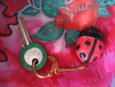  Picture 2: A ladybird pendant | 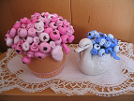  Picture 3: a bunch of flowers | 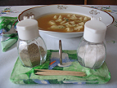  Picture 4: a base for salt, pepper and tooth-picks
  Pictur5: a medal | 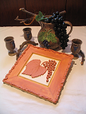  Picture 6: a picture | 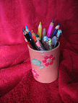  Picture 7: a pot for pencils |   Picture 8: a name’s letters
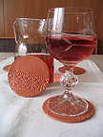  Picture 9: bases for glasses |   Picture 10: a necklace | 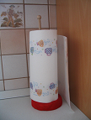  Picture 11 :a base for paper towels | 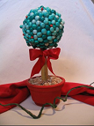  Picture 12: a tree
  Picture 13: a new year decoration |   Picture 14: candlestick | 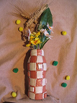  Picture15 : a vase “mosaic” |   Picture 16: a pendant
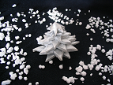  Picture 17: a christmans tree | 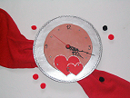  Picture 18: a clock | 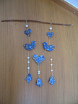  Picture 19: »mobili« | 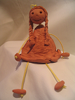  Picture 20: a hanging dancer

CONCLUSSION

We live in a time of mass communications. Nowadays a child absorbes a lot more information before going to school. It often happens that a pupil does has no eagerness for work. The main reasons for this can be that he is not motivation or active involved in the lesson (discussion of the subject).
Project based learning has a lot of advantages in comparison with classical learning. Pupil release their creative energy in an active work. They are active all the time because they are included in all stages of the project – from recognising the problem, planning and preparation of work to elaboration and evaluation. Project based learning gives the pupils an opportunity to recognise and improve their abilities. It also orientates them towards active collaboration at learning. The teacher along with pupils forms the proceedings of the project. In this the teacher is only an adviser, whereas the pupils have the main role.

LITERATURE
- Bezjak, J. (1997): Projektno učno delo pri pouku tehnike kot uspešna oblika in metoda sodobne inženirske pedagogike. Ljubljana: Zavod RS za šolstvo in šport.
- Bezjak, J. (2003): Idejni projekti ob tehniških dnevih. Ljubljana: Somaru.
- Novak H. (1990): Projektno učno delo, drugačna pot do znanja. Ljubljana: Državna založba Slovenije.
- Papotnik, A. (1993): Zgodnje uvajanje v tehniko. Maribor: Založba obzorja.
- http://www.mszs.si/slo/ministrstvo/organi/solstvo/viprogrami/os/9letka/predmetnik/predmetnik.

