DEVELOPMENT OF A PROTOTYPE PRODUCT, INTRODUCED TO PRIMARY SCHOOL

Jože Štrukelj, Prof., The Vič Primary School, Ljubljana, Slovenia

ABSTRACT

Due to the approach based on a round off and complex issue, project school work can be organized in such a way that it corresponds to the capabilities and interests of a great number of pupils; it also represents stimulation for each pupil to prove oneself at different occasions. Thus from the manufacturing of wooden chairs, which does not suit all pupils equally, a broader project evolved, which consisted of a systematic arrangement of different technical know-how in a logical sequence. There, pupils can independently, with indirect assistance of their tutor, empirically gain certain knowledge, learn different facts and draw conclusions.

Key words: project school work, macro-scale project preparation, micro-scale project preparation, prototype, technical-technological product documentation, conceptual outline, workshop sketch and drawing, design drawing, dowelled joint.

CONSIDERATION OF THE NEEDS, INTERESTS AND CAPABILITIES OF PUPILS IN PROJECT SCHOOL WORK
Consideration of interests is a precondition for appropriate motivation and participation in a project. The interests pupils have developed have to be recognized and taken into account and by way of active participation in different activities pupils should be enabled to discover and develop new interests. ^{[1]}
It is important that the form of teaching is of the open type, where a teacher can pay attention to pupils and their interests. Each participant in project work should be in an equal position regarding other participants. Thinking, proposing incentives and solutions as to the most appropriate modes have to be performed in a relaxed atmosphere. ^{[1]}
By accepting various tasks pupils are expected to act independently and responsibly within project work. Clear enough, the tasks should be in line with their capabilities. They should be given the opportunity to choose between differently demanding activities, various implementation ways and different tools. ^{[1]}
Due to the approach based on a round off and complex issue, project school work can be organized in such a way that it corresponds to the capabilities and interests of a great number of pupils; it also represents stimulation for each pupil to prove oneself at different occasions. ^{[1]}

PROJECT'S CONCEPT
Manufacturing of small wooden chairs in the 8th class of primary school (eight-year educational program) has become a tradition in our school. Already the pupils of lower classes discuss the idea that when they are in the last class they will also manufacture a chair of their own. It is often the case that wishes actually exceed pupils’ capabilities. Later, during the manufacturing of the object, it often turns out that practical work is not equally suitable for everyone. Based on the experience of many years and mistakes which came up, I extended the manufacturing of a practical product to a broader project. It includes:
- wishes and capabilities of the majority of pupils,
- know-how from different fields,
- empirical learning, enabling pupils to gain new experience,
- participation of pupils in planning,
- the use of a great number of senses in order to link thinking with practice, school with life, theory with practical work.
The eight-year educational program approaches its end and there is no technical science subject in the 9th year of the primary school program. Therefore it would be best to carry out this project within the optional subject, called Working of materials – woodworking. Yet because of the fact that three different age groups of children (7th, 8th and 9th class) can participate in the same group of this optional subject, the basic goals of the project would remain the same, only some issues and the organisational part of the project would have to be modified to some extent.

MACRO-SCALE PROJECT PREPARATION
DEVELOPMENT OF A PROTOTYPE PRODUCT, INTRODUCED TO
PRIMARY SCHOOL
PART 2
3D conceptual outline
setting the product's price
during practical manufacturing of a product a pupil adapts measures izdelavo izdelka učenec prilagaja mere
motivation stimulating introduction
calculation as to material quantity
PART 3
PART 1
setting the criteria used with the development of a new product
additional skills in drawing isometric projection projekcije
a pupil realises by himself that he needs more measures than originally planned
drawing workshopdrawingsof individual components
elaboration of technical and technological product documentation

MICRO-SCALE PROJECT PREPARATION

 | 1. partial task | 2. partial task | 3. partial task
 | DEVELOPMENT OF A NEW IDEA AND PREPARATIONS FOR THE MANUFACTURING OF A CHAIR PROTOTYPE | PRACTICAL MANUFACTURING OF A CHAIR PROTOTYPE | ELABORATION OF TECHNICAL AND TECHNOLOGICAL PRODUCT DOCUMENTATION AND CALCULATION OF THE PRODUCT'S PRICE
WHAT? | - motivation introduction to the project,  - setting criteria which will be observed in the development of a new chair,  - drawing of a conceptual outline in perpendicular projection,  - 3D conceptual drawing of a chair ➔ additional knowledge ➔ pupils get acquainted with new educational contents: drawing of spatial (isometric) projection of quadratic prisms and cones,  - workshop sketches of an individual component,  - calculation of material quantity to be purchased in a shop or at joiner's, | - during the manufacturing of a chair a pupil adapts and corrects the measures on a conceptual outline and workshop sketches, | - by means of a manufactured chair a pupil elaborates technical product documentation for the chair (design drawing and workshop drawings) and produces a parts list and technological implementation plan; drawings are made in CiciCAD software,  - sets the product's price,
HOW? | - with the knowledge he already has and additional know-how in the field of technical drawing,  - by means of two-way teacher-pupil communication,  - with the help of science teacher, | - with a conceptual outline made in perpendicular projection and workshop sketches,  - on the basis of pupil's knowledge, skills, experience and creativity,  - by using different machines, tools and instruments,  - by taking into consideration safety measures at work,  - with the help of a science teacher, | - with drawing knowledge he already has in CiciCAD program, practiced in the previous years,  - with the help of a science teacher,
WHERE? | - in a science classroom, | - in a science classroom, | - in a science classroom,  - in a computer classroom,
WHEN? | - within regular classes (approx. 8 hours), | - within regular classes (approx. 14 hours), | - within regular classes (approx. 6 hours),
WHO? | - pupils,  - science teacher, | - pupils,  - science teacher, | - pupils,  - science teacher,
BY MEANS OF WHAT? | - with a short documentary film on a renowned Slovene artist and designer Teodor Lorenčič,  - by having a look at a catalogue issued by Slovenian painter Domen Slana at the occasion of the exhibition entitled »Chair«,  - with model chair samples,  - with a model sample of a conceptual outline,  - with instruments for technical drawing, | - machines (jigsaw, band grinding machine, hand and table boring machine),  - tools (try square, hand saw, roughing files, joiner's straps, centre punch),  - appliances (sand paper, sand board, brush), | - computer program CiciCAD and the application for setting the product's price: Calculations,  - by means of an already manufactured chair,
WHY? | - a pupil researches, discovers, gets acquainted with, forms, constructs a simple technical object,  - gives reasons for drawing of objects in a perpendicular and spatial (isometric) projection,  - develops freehand drawing,  - develops his spatial imagination. | - gets the meaning of corresponding machines, tools and appliances and learns how to properly use them,  - develops motor skills,  - develops creativity and precision in product manufacturing,  - develops working habits and gets to help others,  - practical work is a motivation means to achieve goals later on. | - elaborates entire technical-technological product documentation,  - analyses his own work and evaluates it, sets the product's price according to the criteria set in advance,  - finds examples of the use of such a product in his environment,  - a pupil transfers the product's development procedure learned during previous classes to the field of his interest (his future profession).

This project gives pupils the role of a prototype product’s constructor, employed in the furniture industry. The first part of the project, taking up about 8 hours, is intended for the development of a new idea and the preparation of chair's prototype manufacturing. It starts with a motivation stimulating introduction, when a teacher presents a catalogue of chairs by a renowned Slovene artist Domen Slana. By means of unusual chairs, made of ancient farmers' tools combined with new wood pieces, the artist wanted to convey the idea that a chair is not merely an object to sit on but it can also put our imagination to the test. Pupils also have a look of a short documentary film entitled Woodworking, the topic of which is the Slovenian artist and designer Teodor Lorenčič, who has quite a unique attitude towards wood. One of his statements – later on one of the criteria observed in the concept development – is that construction should not pay tax to aesthetics. Before pupils start to work on the elaboration of the conceptual outline, they set – together with their teacher – the criteria that will be observed during the entire project:
- a product should be made of spruce or pine wood; metal, cloth or simple intarsia can serve as ornamentation, the latter, however, is optional;
- basic dimensions of a chair are on a scale of 1:1,5 (more favourable as to the price, an answer for not having enough room),
- individual component parts are going to be joined by a dowelled joint,
- product's complexity is going to be adapted regarding the age group of pupils and machines, tools and instruments which are at disposal in a classroom,
- a product must be useful and comply with the criteria of aesthetics.
A conceptual outline can be drawn in any projection. The majority of pupils choose perpendicular projection, since they have studied it before in previous classes, and is also less demanding as to the point of view of spatial imagination. While pupils are drawing, a teacher gives individual instructions, consultations and expects such complexity of the conceptual outline that a pupil will be able to put it into practice primarily by himself. A pupil also enters basic chair's dimensions after the instructions of his teacher (height of legs and length and width of the seat), all other measures are optional yet within sensible limits. With teacher's help he realizes that a 3D drawing is much more pleasant for product's presentation. In this project's phase, introduction of new educational contents starts: drawing of spatial (isometric) projection of square and cylindrical shapes. The last task within this phase is the conceptual drawing of a chair, made in isometric projection.This is followed by the calculation of material quantity to be purchased in a shop or at joiner's. While making the calculation, a pupil realizes that apart from basic measures other measures of individual component parts of the chair are also required if he wants to find out how much material he needs. Here is the role of the teacher, who points out the meaning of a workshop drawing, design drawing and parts list to the pupil, who afterwards also elaborates them.
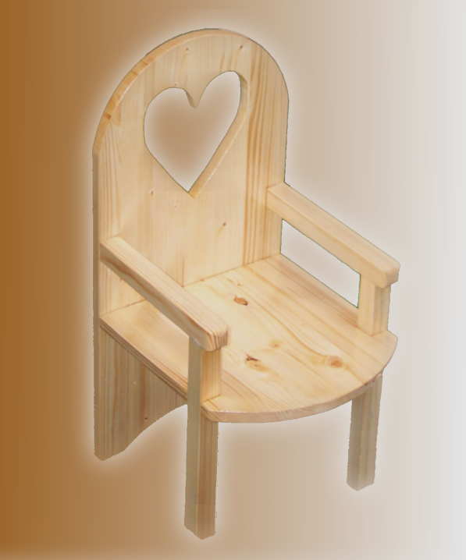 | 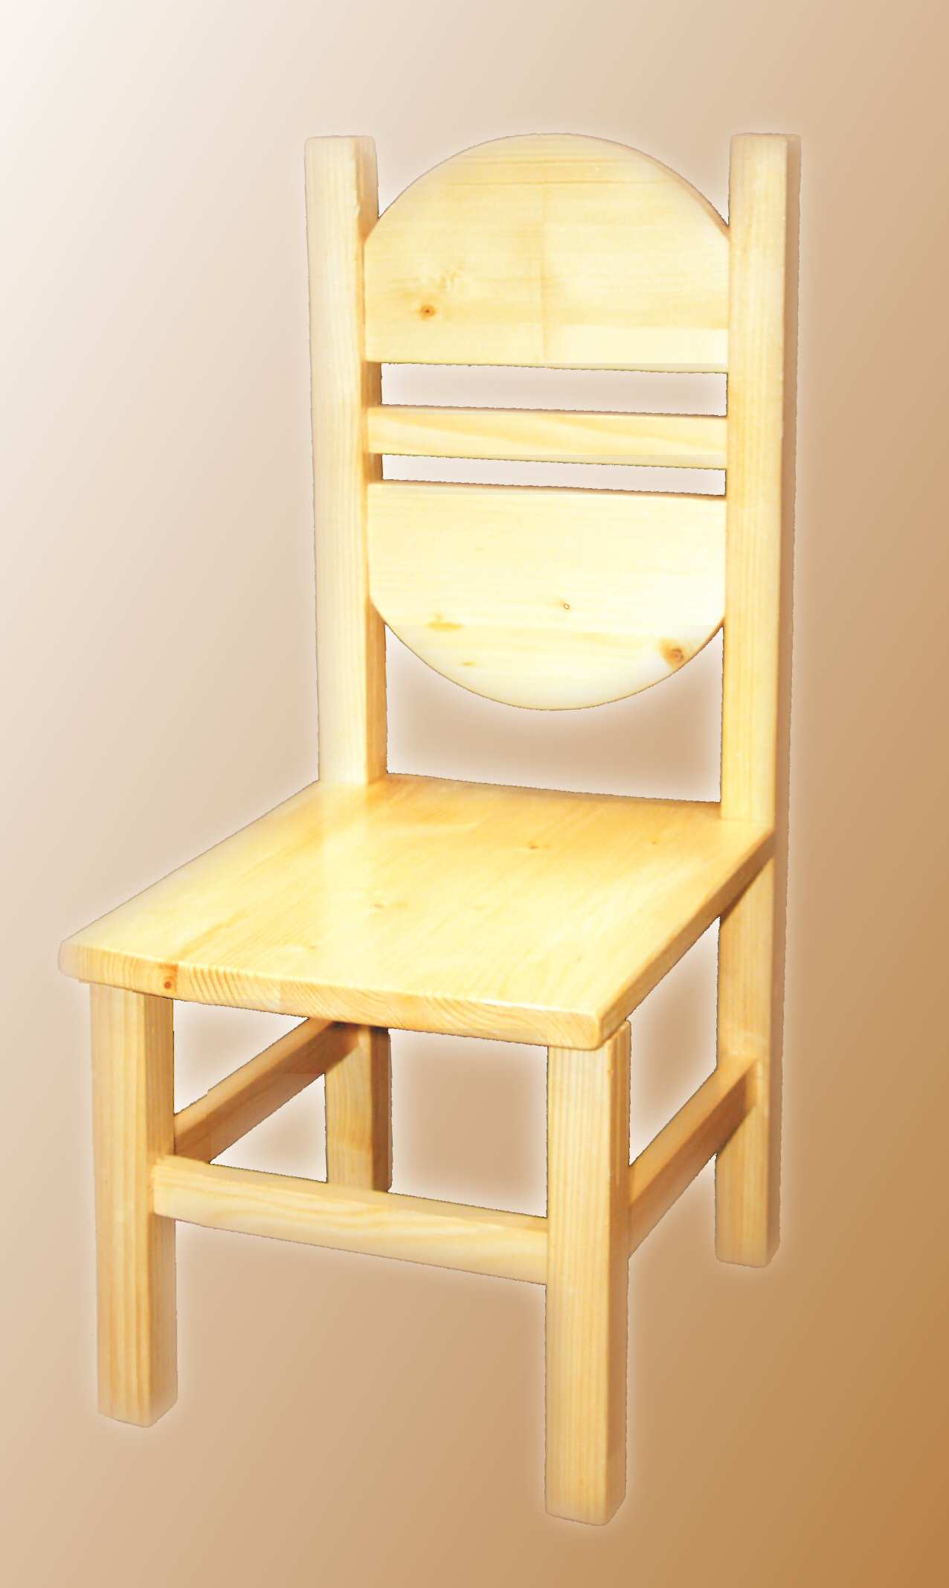 | 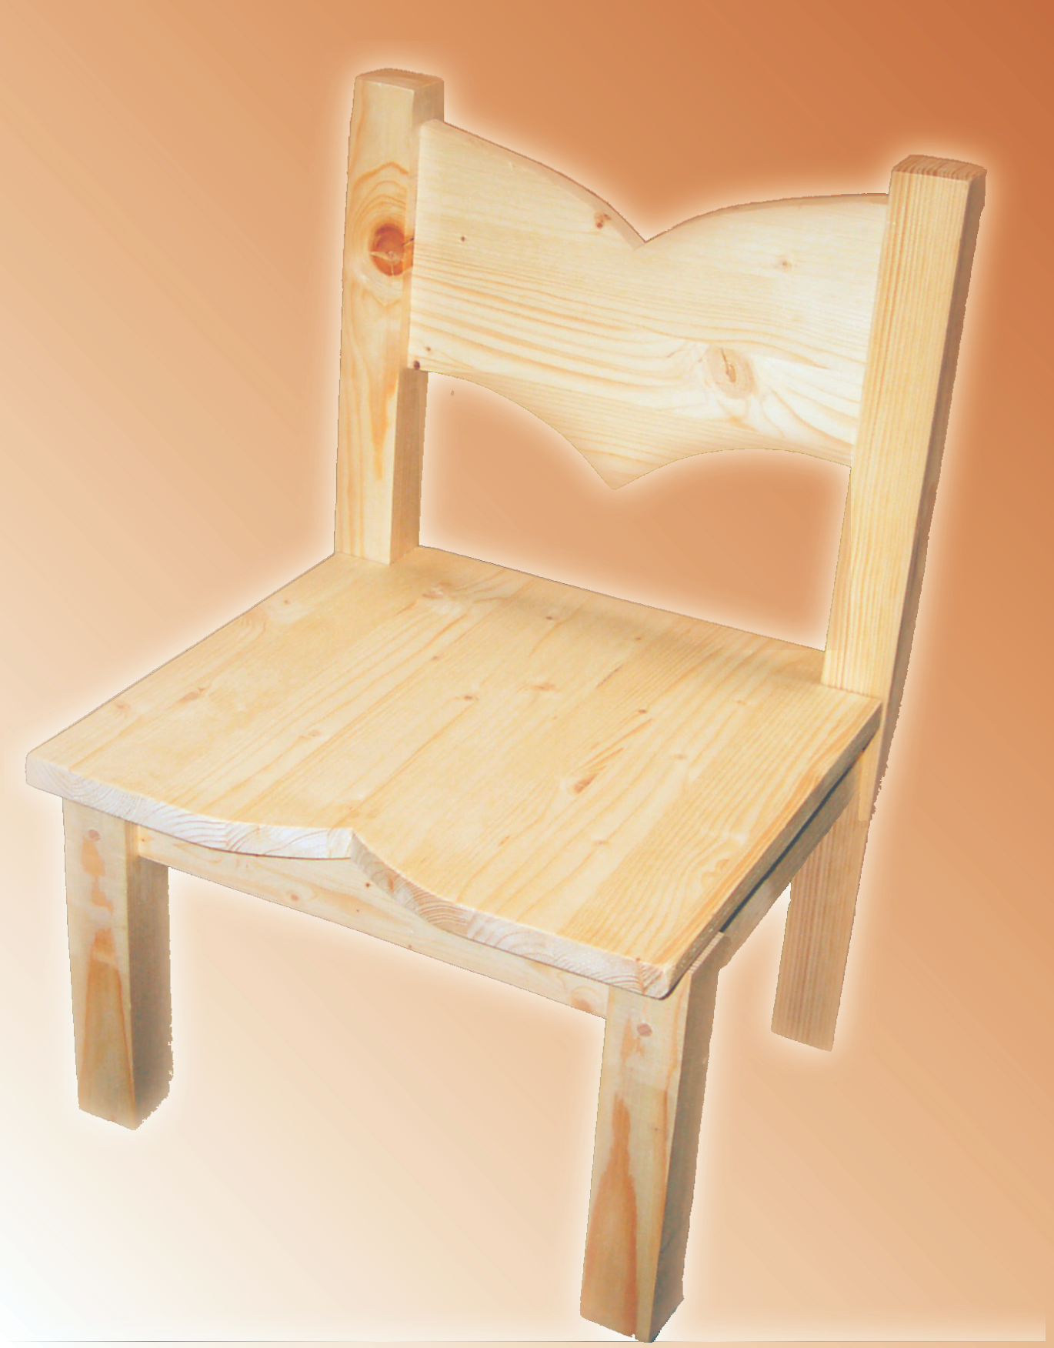
Pictures 1,2,3: Produced by 14 and 15 years old pupils

In the second part of the project, pupils proceed with the manufacturing of their chairs. Before they start the machines, the teacher raises safety at work issue, they discuss discipline that should be maintained in the science classroom and which machines and tools are suitable for individual work operations. During the production pupils read their workshop drawings under the tutorship of their teacher, they draw on wood, saw wood, grind it and – if necessary – adapt and
correct measures in the conceptual and workshop outlines. A chair is manufactured according to a sequence arranged in advance. At first, the rear legs of a chair are made and the back of a chair is shaped out of a board; all three parts are joined with a dowelled joint. Before boreholes for a dowelled joint are drilled, the centres of holes should be marked precisely. In this work phase pupils’ attention should be drawn to the fact that without precise drawing it is futile to expect that component parts would fit. The back of a chair permits the most creativity. Yet the teacher is supposed to learn them about wood structure (annual rings’ direction). Next, front legs are made, followed by joining bars between legs, which are to be joined in the same manner. In the end, the seat is formed, adapted and fixed. Immediately after being glued together, all joints have to be pressed with handscrews for so long that glue starts to bind. Finally, pupils grind sharp edges of chairs and protect them with colourless varnish.

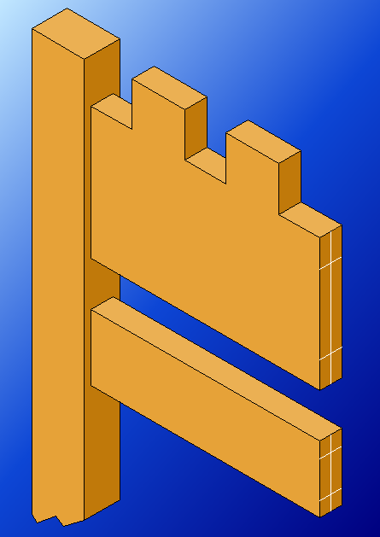 | 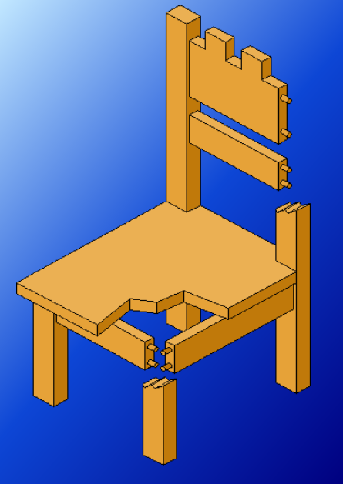
Picture 4: Hole centres for a dowelled joint  have to be marked precisely | Picture 5: Presentation of chair assembling  with a dowelled joint.

In the third part of the project pupils elaborate technical and technological product documentation: a design drawing, workshop drawings, a parts list, and a technical implementation plan. If possible, this should be done in CiciCAD program. The project concludes with the calculation of the product’s price. Each pupil calculates the price of their chair, using the Calculation computer application. The price comprises:

- the cost of material,
- the cost of an individual working phase per hour:
machines’ and devices’ depreciation costs,
- power needed for machines’ operation,
- heating costs,
- illumination costs,
- environmental tax,
3. time used for an individual working phase,
4. other costs:
- worker’s earnings,
- waste material’s share,
- VAT.

It is of great importance that the program enables pupils to discover which price’s component influences the final price at the most. They can “browse” the program, change individual price parameters and see how the price is affected thereby. They will establish that final price mostly depends on work costs.

SUMMARY
The purpose of this project is not to invent that which has long before been invented; it is, however, to arrange the knowledge in the field of technics, which has already been passed on from teachers to pupils for several years, into a systematic sequence. Its goals thus is that pupils independently, with indirect help of their teacher, empirically gain certain knowledge, learn new facts and draw conclusions. The role of a constructor employed in a prototype department of the furniture industry, which is assumed by pupils, requires the use of several senses because thinking should be combined with practical work in this profession. Consequently, such a project makes strong impression regarding technical professions on many a male or female pupil, opening them new horizons as to their vocational priorities.

LITERATURE

- Bezjak, J. (2001). Didaktični oblike dela pri pouku tehnike. Ljubljana: LVM
- Novak H. (1990). Projektno učno delo, drugačna pot do znanja. Ljubljana: Državna založba Slovenije
- Bezjak, J. (1997). Projektno delo pri pouku tehnike, kot uspešna oblika in metoda sodobne inženirske pedagogike. Ljubljana: Zavod RS za šolstvo in šport.
- McGuire K. (1993). Woodworking for Kids; 40 Fabulous, Fun & Useful Things for Kids to Make; New York: Sterling Publishing Co.
- Slana D. (1998). Stoli Chairs. Kranj
- http://www.cicicad.si/ (CiciCAD 2.5 software)
- http://www2.arnes.si/~osljhrnhr1/ (Kalkulacije 3.5 software)

