PROJECT EDUCATIONAL WORK IN AFTER SCHOOL CLASS OF THE SECOND GRADE OF NINE YEAR SYSTEM PRODUCING HATS FROM DIFFERENT FABRICS

Marija Baš, teacher of supervision and care in Prežihov Voranca Primary School, Jesenice

ABSTRACT

In after school class (second grade of nine year system) I performed the project : Producing hats from different fabrics. This project work might be a very good activity for these children, when they need some relaxation after school and they want to develop their interests and skills. All educational fields are equally presented. It is important to have a good motivation, participation of parents, other co-workers at school and outside of it .The project consists of three main parts. In project the pupils discover the hats from past to present time. First they produce the hats themselves, then they appear with them on the fashion show and finally they make a hat exhibition in the school hall.

Key words: after school class, guided activity, 7-years old children, macro plan, micro plan, hats, waste material, clothe material.

GENERAL ABOUT PROJECT EDUCATIONAL WORK
When selecting the project theme, I was fully aware of pupils’age and interests. This is very important for their motivation.^{[1]}The same educational theme is treated from different points of view with a special emphasis on experience learning.^{[1]} Project educational work is based on flexibility and openness so that all the activities are aimed to develop the complex pupil’s personality.^{[5]} In this project work we should calculate development phases in the pupil’s mind, which is on the level of practical mind – practical intellectual operations.^{[2]}The main performer is the pupil, when the teacher is the initiator and guide of the child’s activity. The activity concept is running after fixed plan. Pupils and the teacher are planning it together.^{[1]}It is important that a teacher is creative and open minded who freely express his creativity and capabilities. Only as such gives the possibility to children that they can discover and confirm their interests^{.[1]}Project work seems to me very qualitative because we equally connect different subjects. This differs a lot from the traditional learning.

POSSIBILITIES OF PROJECT EDUCATIONAL WORK IN AFTER SCHOOL CLASS

After school class is an extended way of educational work which is organized after the regular school lessons. It consists of four elements: lunch, relaxing activities, individual learning and creative time. At last activity, the pupils decide how to spend their time according their interests and capabilities. It is important that they actually feel the creative time. This influences their good feelings and personal development. Activities are well planned, aimed and organised.^{[1]} Pupils gain capabilities on different areas of human work. Amongst them are also hard work and technical skills.Preparations that are planned for after school classes can be also in the form of project educational work. In my seven-year experience I found out, that this sort of performance is very appropriate for children and in the end they are very satisfied with themselves.In project preparations we decide aims, methodology and means. In the end we make evaluation that gives us a report for a teacher as well as for pupils.
The teacher’s role is very important, because we have to adapt to children, guide them without any force, stimulate them to finish their work, give them some reward, be happy with them and listen to them when they are sad or in trouble.The pupils normally have a lot of other afternoon activities beside after school class. So I should be very careful and have always new ideas on my mind how to stimulate them to finish their started work.The parents are almost spontaneously included in our projects by collecting waste material that we use for technical and art activities. They acknowledge our work and find out that we teachers of supervision and care give an important contribute to their child’s development. With insight into our work they realize that after school class is not only writing their homework. I believe good communication with parents is of outmost importance at my work. This is the way I get to know pupils very well and it gives me better teaching performance. Then it is also important to have good contacts to other personnel of school team such as:head mistress, school teachers, subject teachers, librarians, cooks and school keeper.

PROJECT PERFORMANCE IDEA
I am teacher of supervision and care, employed at Prežihov Voranc Primary School and this year I am teaching in after school class for second grade of nine year system. The pupils are 8 years old. There are 28 children in the group.

IDEA SUGGESTION

Suggestion for producing hats I received last year, when I was teaching , together with my colleague, in first grade of nine year system. We put a lot of attention to celebrate seasons of the year. Therefore in autumn we were visited by Auntie Autumn, in winter by Snowy queen, in spring by Spring Fairy. We acted all this roles with special costumes. Children were very interested in hats which we produced for each season. When a new school year began, it was easy to motivate the pupils how to make hats according our ideas.

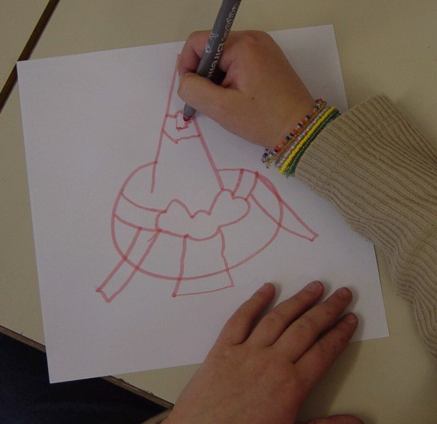
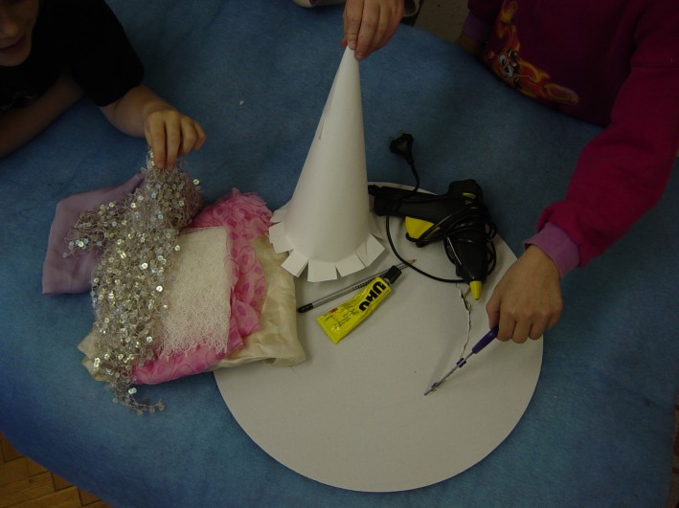

Picture 1:Clothe material Picture 2: Hat sketch

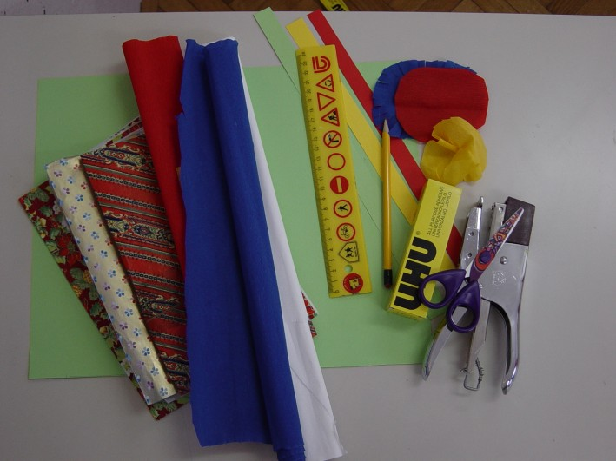
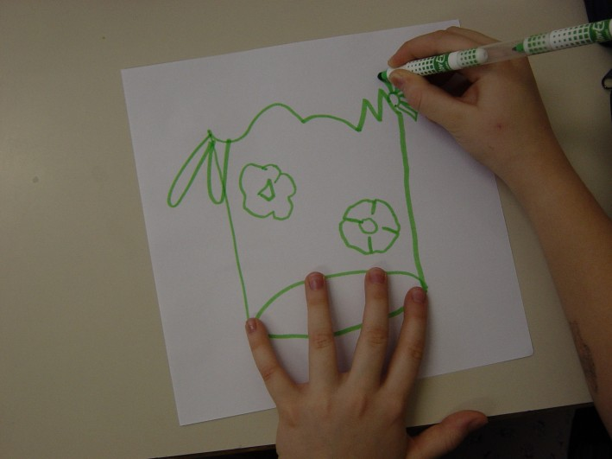

Picture 3: Hat material from paper Picture 4: We draw hat sketch

CORRELATION

In the project all the activities from different educational areas are connected and equally presented:
- technical activities,
- communication (drama) activities,
- art activities,
- natural science(research) activities
In the project are demonstrated activities from manual technical education.

PREPARATION FOR PROJECT PERFORMING

As at this age, pupils do not have long endurance and very well developed manual skills. I arranged the aims to their capabilities. I considered that children after hard work in regular class lessons needed relaxing time. So I manage to find a project which is fun, but also gives certain habits and learning how to:
- prepare and clean the working place
- follow the instructions
- taking part in solving common tasks
- individual work
- planning their own tasks

Besides that they are taught how to use scissors, how to act carefully and economically with material, by drawing hats they develop their creativity and endurance.When I inspired children with the idea of producing hats, we started the macro project. The pupils gave their own ideas. We overviewed the ideas and then decided for those, which can be realized. We put down all the ideas on the poster. Then each day we talked it over how to perform and continue our work.
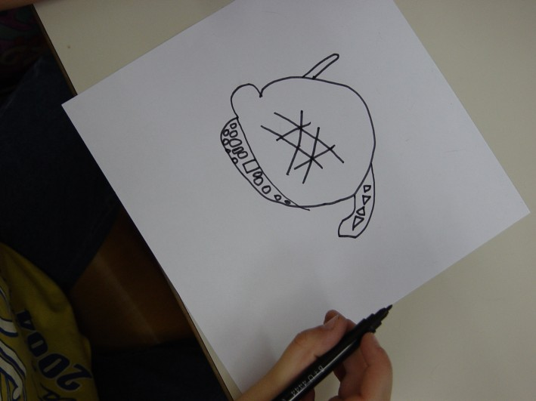
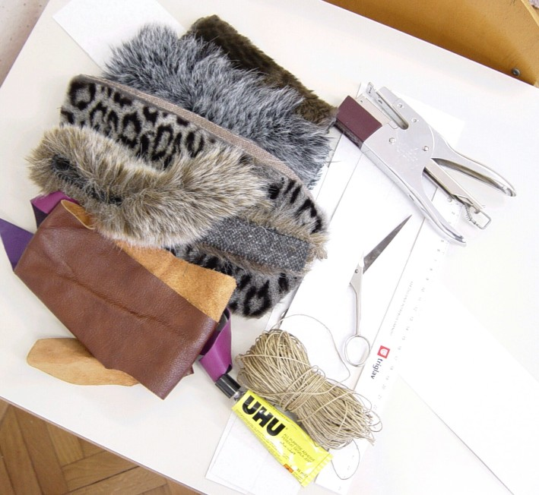

Picture 5 : Sketch for the fur hat Picture 6: Material: artificial fur, leather, string

MACRO PLAN
- We collect ideas and write macro plan on poster.

- We visit the theatre and shops where we look at hats.

3. In the library we look for literature of hats.

- We search waste material for hats.

- We draw sketches and cut them out.

- We make hats.

- We present hats in a fashion show and exhibit them in the school lobby.

MICRO PLAN
FIRST PART OF PROJECT
BOOKS ON HATS
VISITING THEATRE AND SHOPS WITH HATS
WHAT? | - We look for books on hats in the library,  - We read the book Klobučki,  - In the theatre:  - hat fashion in the past,  - way of producing hats,  - Shops with clothes:  - hat fashion nowadays,  - fabrics for hats.
HOW? | - With discussion  - With listening  - By observing
WHERE? | - In Tone Čufar Theathre  - In clothes shops  - In the library
WHO? | - Pupils, teacher, theatre employee, shop assistant, librarian
WHAT WITH? | - Appropriate behaviour in the theatre, shop and library
WHEN? | - At the beginning of the project, in the after school class
WHY? | - We compare fabrics for production from past to present  - Recognizing different hats for different occasions  - Learning how to search the literature

SECOND PART OF PROJECT
PRODUCING HATS

WHAT? | - We go through basic plans for hats,  - Children draw their own sketches for hats,  - We choose fabrics and tools,  - We cut, glue or staple the basic paper model and put them on,  - We use the chosen fabrics.
HOW? | - With basic plan,  - With pupil’s creative ideas,  - With teacher’s support,  - With special fabrics, tools
WHERE? | - In after school class
WHO? | - Pupils, teacher
WHAT WITH? | - Tools: scissors, stapler, glue pistol (used only by a teacher, dangerous because of burn outs)  - Additional items: rulers, glues, silicon glue, pencil, marker, different pieces of paper (white, coloured, wrapping) artificial fur, wool, leather, string, clothe material.
WHEN? | - in the after school class,
WHY? | - We develop creativity, imagination, drill our manual skills and handling with different material  - We recognize value and use of waste material,  - Looking forward to their product

THIRD PART OF PROJECT
FASHION SHOW

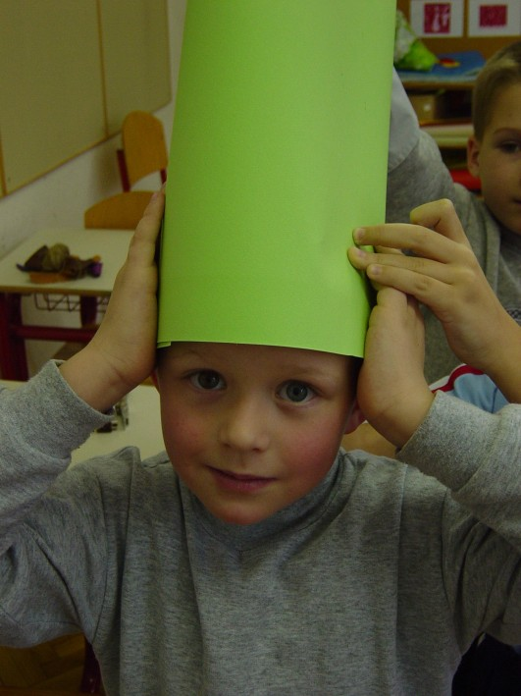
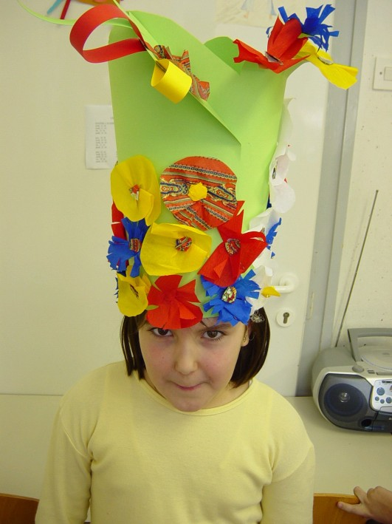

Picture 7: We measure the size of our head Picture 8: Florist's hat

WHAT? | Exhibition hall :  - Trying on hats and improve them so that they fit,  - We present hats on fashion show to other after school classes, accompanied by music  - We decorate the hall wall with them  - Observing changes in fashion when selecting PVC bags
HOW? | - Pupils supported by teacher and school keeper,
WHERE? | - After school class, hall,
WHO? | - Pupils, teacher, school keeper, parents, other schoolchildren
WHAT WITH? | - With produced hats  - With poster where macro project is written  - CD player
WHEN? | - In after school class, after finishing the project
WHY? | - Learn how to use waste material usefully,  - Receiving new ideas for new hats,  - Learn how to appear before other people  - Stimulate other school children to look for their own ideas.

CONCLUSION

In this project 14 pupils were included. We presented 3 types of hats from 3 different fabrics. Performing our activities was not so easy because some children left quite early. They learned how to cut, glue and then they accomplished their ideas with which were very happy to see their products. They received a lot of rewards from their parents and school employees. Those children who did not produce hats were active in other activities such as communication, music, so they were involved as well. Finally pupils found out they were capable of things that they never believed they could have done.

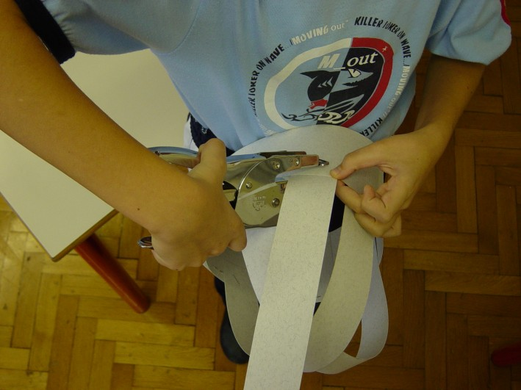
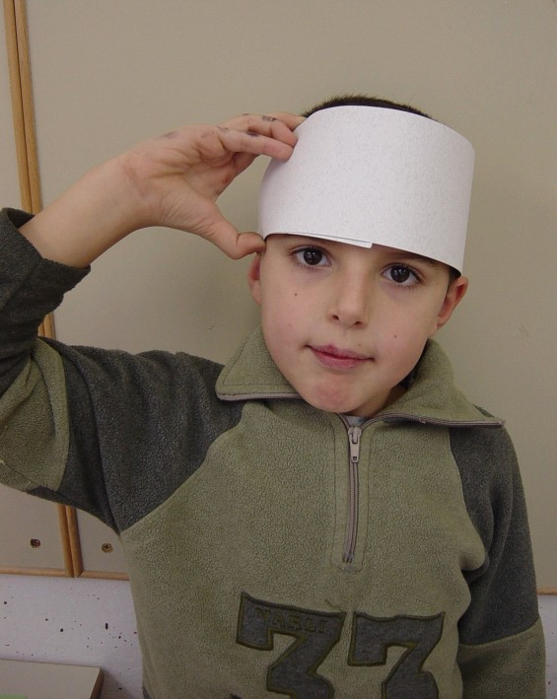

Picture 9: We measure size of our head Picture 10: Hat belts stapled with stapler

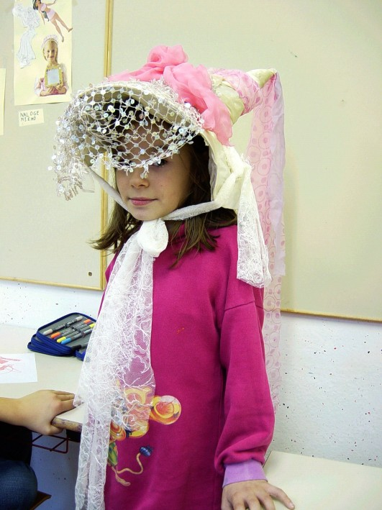
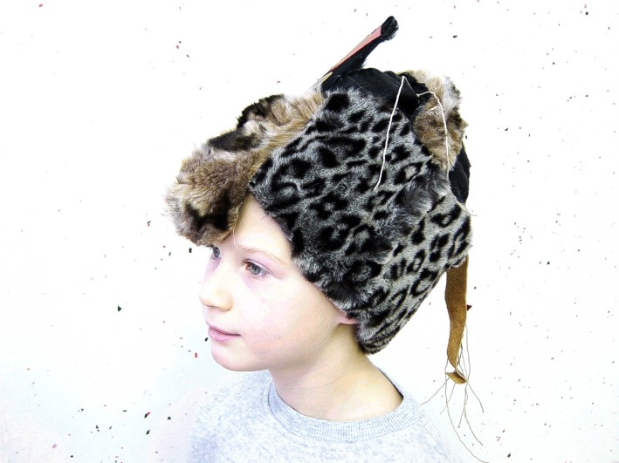

Picture 11: Princess hat Picture 12: Indian’s hat

LITERATURE
- Kos, Knez S. (2002): Vzgojno izobraževalno delo v podaljšanem bivanju v devetletni osnovni šoli, Zavod Republike Slovenije za šolstvo: Ljubljana.
- Novak, H. (1990): Projektno učno delo: drugačna pot do znanja, Ljubljana: DZS.
- Lipar, Kadunc G. (1992): Oblikujmo sami, Radovljica: Didakta.
- Lipar, Kadunc G. (1989): To zmorem tudi jaz, Ljubljana: DZS.
- Papotnik, A. (1992): Prvi koraki v projektno nalogo: projektni način dela pri tehniki na razredni stopnji, Radovljica: Didakta.
- Volčič, M. (1994): Klobučki, Radovljica: Didakta.
- Warne, R. (1995): Oblačila, Murska Sobota: Pomurska založba.

