PROJECT work in a vocational school SOLAR STOVE ˝FROM THE IDEA TO THE PRODUCTS˝

Valentin Peternel, B. Sc. El. Eng., Zdravko Žalar, B. Sc. El. Eng., Jože Virant Vocational School for Technical Sciences, Ljubljana, Slovenia

ABSTRACT
Today it is hard to find a place on the earth that is not polluted or influenced in one way or the other by us, the humans. Pollution, which comes from intense industry, traffic and farming, is becoming bigger every day. Pollution substances that come from urban regions spread trough the air over bigger territories. Thus the air gets polluted even over remote places, for example over the high, mountings lakes. It is a fact that today we burn more fossil fuels, and that does not make good influence on the nature. The greenhouse effect, the enlarged emission of CO₂ , pollution of air and forming of holes in the ozone layer are the consequences that fossil fuels leave behind. To preserve our planet from further destruction, we need to adapt our ways of acquisition of energy to the rhythm of ecosystems. One of the solutions is exploiting the solar energy.By means of the data and the information’s from web sides we worked out a solar stove. The teachers of general subjects and the teachers of professional theory cooperated in this project work. The students were also included in partial tasks of this project. First some partial tasks like working out a solar stove, technical and technological documentation were included in learning process at subjects: technology, drawing and machine elements and practical work. In the next step we tried to connect learning matter at physics and mathematics with phenomena that is playing in the solar stove. At English language we achieved some general aims above all with studying materials from web sides. The initiator of this project was the principle Mr. Zdravko Žalar. But the project work began to live because of excellent cooperation of physics teacher Mr. Valentin Peternel and practical work teacher Mr. Jože Virant.

Key words: solar stove, solar oven, solar furnace, density of heat flow rate, power of solar stove, heat, temperature, convection, radiation, conduction of heat, reflection of light, absorption of light, parabola, paraboloid
- presentation of the project WORK
The use of alternative sources of energy is subject that young students should deal with it in secondary school. With this project we tried to inform our students with possibility of exploiting the solar energy. Beside this we tried to initiate the project work at general and professional subjects. With our work we went towards that sort of teaching that should take place in vocational school. It concerns the idea of that sort of education and qualification, when the students is preparing through the whole studying to the ending product. All the teachers who teach the subjects of the certain program should cooperate with their own contribution.

A group of teachers was formed that worked out with a help of students a project work – the solar stove. The students were forms in different groups. Each group has it owns partial task:

- Group made out a technical documentation,
- Group made out a technological documentation,
- Group made out a solar stove,
- Group was has to make measurements,
- Group was searching the data and the information with that sort of technology in the world,
- Group has represented our project work on national competitions and meetings.

- SUN ENERGY
From the beginning of the scientific way of thinking the energy source of Sun was one of the most interesting and on the other hand one of the most difficult puzzles of the nature. Since last century it was possible to exploit sun energy on the manner that is commercial and technological justified. The power of radiation of the Sun is about 0.5 quadrillion of kilowatts. Only two parts of milliard of that energy flow the Earth receives. The radiation that all the others planets receive doesn’t exceed one thousandth percent of the whole emitted radiation. The amount of 99.99 percent of the Sun radiation is lost in the space.
Sun energy comes to the Earth in the form of electromagnetic waves. Approximately 47% of that energy is visible light, 46% infra red ( IR ) light and 7% ultra violet ( UV ) rays.The whole potential of the sun radiation in Slovenia amounts to around 23000TWh, which is over 300 times more than our usage of primary energy. Some new studies show that the technically disposable potential is 960GWh per year with technologies that we possess today. This is approximately the same as half of the electricity produced by the Nuclear Power Station Krško (NEK). The data of the number of the hours of solar radiation for some places in the year 1993 show that there are no essential differences in the duration of the exposure to the sun, except for Primorska region (the coastal area). In general, the data which include the influence of cloudiness can be applied to the whole Slovenian territory. Throughout the year, 1m2 of flat ground receives around 1100kWh of sun energy: approximately 320kWh in the spring, 480kWh in summer, 190kWh in autumn and 110kWh in winter.

- A SHORT VIEW IN THE HISTORY
The usage of sun energy extends to the prehistory, in the land of Mesopotamia, where the priests were using golden polished vessels for ignition the fire on the altars. From the period 287-212 BC a story about Archimedes, who saved a coastal town Syracuse, on the eastern cost of the Sicily, was preserved. The story talks about ignition of the Roman ships by means of sun rays. After Archimedes no progress can be found in the usage of the solar devices till to renaissance. From the 12th century there exists a notation about Proclus who repeated a bravery work of Archimedes, in Constantinople. Several interesting experiments were made out in the 17th century. Athanasius Kircher in Germany, Averani and Targioni in Firence, Ehrenfried von Tschirnhaus in France are the leader researcher in that time. The real development of experiments and devices was in 18th and 19th century. The documents about devices for preparing food, warming of sanitary water, melting the metals, driving machines, distillation of water, etc., was preserved.
Till today many devices that exploit the sun energy were constructed and produced. The review of the sun devices in spite of the limitation on sun ovens would exceed the frame of this writing. That’s why I’ll mention only the solar furnace that was built up in Slovenia. Prof. dr. Ciril Rekar constructed a solar furnace that is shown on picture 1. Institute for Metallurgy in Ljubljana has built experimental solar furnace near Piran at Slovenian coast in the year 1960. The solar furnace with power 1.5kW was built up for research tasks. In the focus of the parabolic mirror a temperature of about 2800ºC was measured. Such a high temperatures are needed for serial of metallurgical researches, for production of extremely clear metals and their alloys, for melting hard meltable materials, etc.

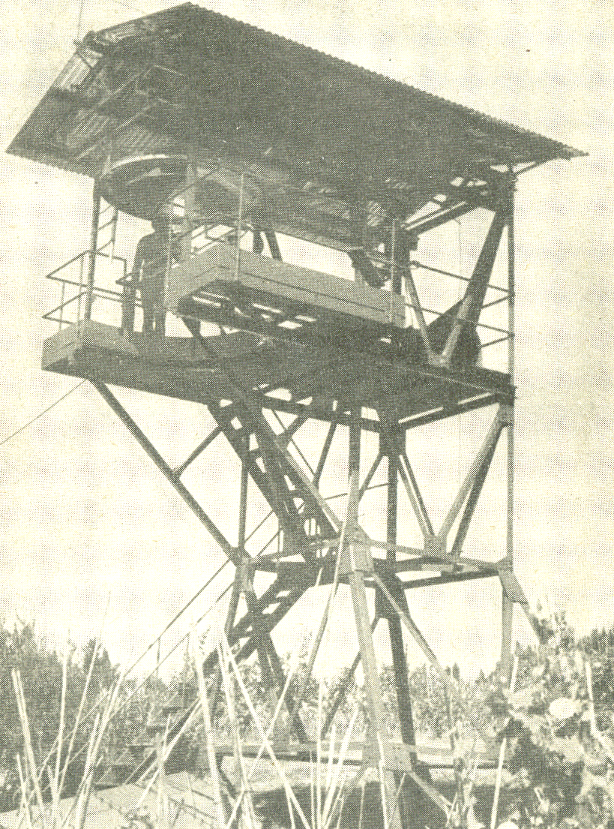

Picture 1 : Solar furnace in Piran
- OUR REALIZATION OF THE SOLAR STOVE
By means of the data and the information’s from web sides we worked out a solar stove. The teachers of general subjects and the teachers of professional theory cooperated in this project work. The students were also included in partial tasks of this project.

Dimension parameters:
- diameter of mirror:  - transverse area:  - focal point distance:  - depth of parable:  - opening for the pot:  - length of the stove:  - width of the stove:  - height of the stove: | 1 400 mm  1,54 m²  280 mm  460 mm  φ320 mm  1 500 mm  827 mm  1 490 mm | 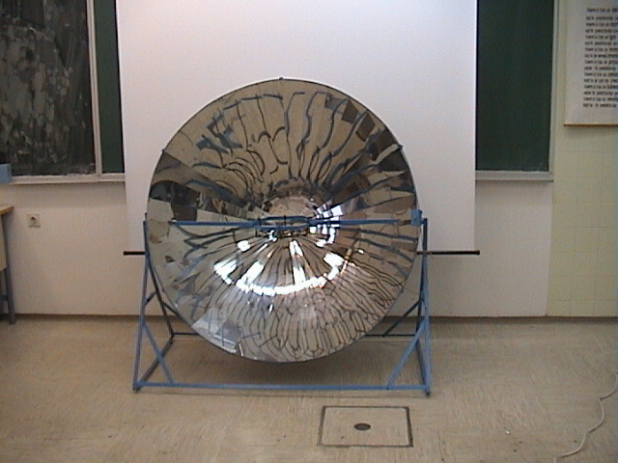
Working parameters:
- power of the stove:  - starting time:  - ending time:  - time of warming up:  - control of the direct incidence of radiation:  - regulation of temperature: | 600 W (estimation)  1 hour after sunrise  1 hour before sunset  15 – 25 minutes  by a screw  deviation from the direction of the incidence of radiation
 |  | Picture 2 : Solar stove

- THE TREATMENT OF THE THEME AT SOME SUBJECTS
First some partial tasks like working out a solar stove, technical and technological documentation were included in learning process at subjects: technology, drawing and machine elements and practical work. In the next step we tried to connect learning matter at physics and mathematics with phenomena that is playing in the solar stove. At English language we achieved some general aims above all with studying materials from web sides.
Similar work might be done at all other subjects of machinery program. The subjects like Slovenian language, energetic, management, etc., would contribute a great upgrade of this project work.

  - INCLUDING THE THEME AT PRACTICAL WORK
The teacher can lead the students from preparing material, production of basic constutient parts, protection of surfaces, to the final mounting the constutient parts. The students of second year of program Designer of metals, produced constituent parts, protected the surfaced and on the end they mounted the solar stove.

  - THE TREATMENT OF THE THEME AT SUBJECT ‘’TECNOLOGY’’
The teacher can lead the students from basic constituent parts and technological methods in the first year to the ending technological proceedings and to final product in the third year. The teacher can teach the students how to choose and use technological methods, starting with the preparation of materials and tools, through the usage of appropriate technology, to the ending control and preparation of the data for marketing the product.
In connection with this subject the students worked out the technological documentation for this project. A part of the whole technological documentation is presented in figure 3.

THE TECHNOLOGICAL SHEET |  |  |  |  |  | Object:  15 MIRROR ROSSETE
 |  | Date: | Name and surname |  | Signature
Produced by: |  | 01.03.2003
Controled by: |  | 01.03.2003
No.: | Working operation: |  |  | Pieces: | Tools, machines and implements: |  | Protection: | Produc. time:
1 | Preparation of materials |  |  | 1 | Rubber |  | Protection clothes, working gloves | 0,1
2 | Marking the shape of element on the material |  |  | 36 | Ribbon meter, pencil |  | Protection clothes, working gloves | 1,0
3 | Cutting |  |  | 36 | Lever scissors |  | Protection clothes, working gloves | 1,5
4 | Marking and pointing the measures for drilling the holes with borers φ7 and φ4 |  |  | 5 | Marker, pointer, hammer, ribbon meter |  | Protection clothes, working gloves | 1,5
5 | Drilling the holes |  |  | 5 | Drilling machine, screwing borers φ7 in φ4 |  | Protection clothes, working gloves | 2,5
6 | Taking off the edges |  |  | 144 | Rough file, blade, vice |  | Protection clothes, working gloves | 1,5

Picture 3 :The technological sheet

  - THE TREATMENT OF THE THEME AT SUBJECT ‘’DRAWING AND MACHINE ELEMENTS’’
The teacher informs the students with basics standard elements that the solar stove is consisted of. The students should learn and receive knowledge about the basic skills for preparing technical documentation. The teacher informs the students with possibilities of drawing and constructing with personal computer, leads and directs them for producing the technical documentation.
In connection with this subject the students worked out the technical documentation for this project. A part of the whole technical documentation is presented in figure 4.

Picture 4 :The part of the technical documentation
  - THE TREATMENT OF THE THEME AT SUBJECT ‘’MATHEMATICS’’
The equation for paraboloid ( picture 5 ) and parabola in x-y plain can be determined at subject mathematics for solar stove. The procedure is definitely simple, if the starting point of the coordinate system is put on the top of parabola. It is necessary to measure only one point on parabola. The most convenient is to choose the point at the end of the parabolic mirror.
The teacher can inform the students with possibility of copying of quadratic parabola over the median line of the first and third quadrant of the coordinate system. On the basis of the parabola equation it is possible to calculate single points and to check them on the product. The formation of the parabola as a cross section of a cone with planes can be informatively presented. I see the main advantage of including the solar stove to the theme mentioned above in motivation element at the learning process.

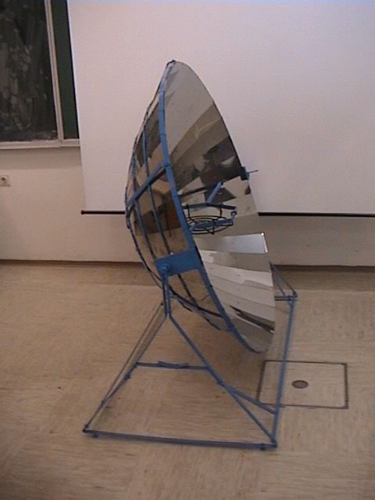 | 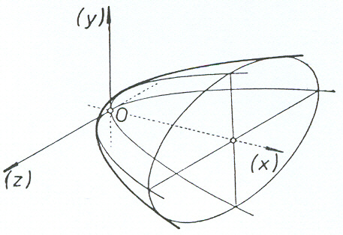

Picture 5: Solar stove and paraboloid

The equation for the parabolid of our solar stove is: z² + y² = 1120x.
The equation for the parabola in the x-y plane is: y² = 1120x.
If we turn the solar stove for 90º, the parabola can be described by quadratic function: y = x² / 1120 .

  - THE TREATMENT OF THE THEME AT SUBJECT ‘’PHYSICS’’
The treated theme can be connected with discussion of the temperature, the internal energy and the optical reflections at the learning matter of the fourth and fifth class of the vocational program of education. Warming the water and measuring the temperature can be experimentally worked out with solar stove. Concrete measured values can be used at the discussion of the energy law. The teacher can use the solar device for demonstration one of the ways of transferring the heat. The solar device is very efficient at learning the basic working conception at mirrors.
At physics we first tried to establish the amount of the density of solar flux that fall on solar stove. We measured that quantity with special measuring device that was made by the students. In this purpose we had to measure the temperature of the measuring plate and the temperature of the surroundings. After ten minutes the temperature measurement was repeated. The temperature was measured with the digital thermometer Impac Tastotherm ( NiCr – NiAl ).

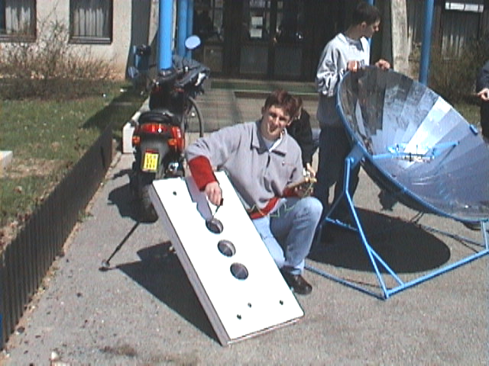 | 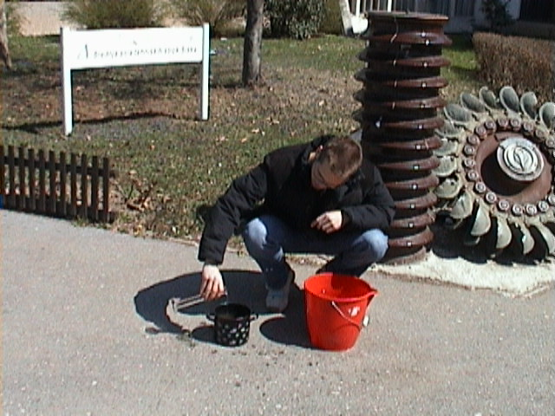

Picture 6 : Measurement of temperature Picture 7 : Preparing the water

In the next step the heat flow rate that fall down to the measuring plate of our instrument was calculated. The starting point is energetic equation, at which is assumed that the difference of internal energy is equal direct incidence of light energy. The light flow rate estimated in such a way assumed to be 4,2W. After calculation the light flow rate that is directed on the surface of measuring black plate, the density of light flow rate was calculated and estimated to 420W/m². That quantity of the density of light flow rate was also directed on the solar stove. Because the cross area of solar stove is essentially bigger than the measuring plate, the heat flow rate will be higher. Cross area through which the light flow rate is directed is equal to the superficial contents of the circle that is made by the external edge of the paraboloid. It is possible to calculate the surface of circle, if the diameter of the external ring is known. So the light flow rate that is directed on solar stove was calculated by means of known density light flow rate and cross area of the solar stove and estimated to be approximately 650W. If we deal with ideal reflection of light, we could say that all light flow rate reflects from the surface of the parabolic mirror. In that case incident flow rate could be defined as a power of our solar stove. Exact data about albedo of the parabolic mirror is not available. We estimated that 90% of incident light flow rate is reflected. In that case the power of our solar device is 600W.
Further estimations, such as the time needed for boiling one liter of water can be made, if we trust the measurements and calculations, mentioned above. First it is necessary to measure one liter of water with measuring cylinder and after that to measure the starting temperature of the water. Already known energy equation can be used for calculating the time of boiling. We estimated that warming one liter of water from 15 degrees of Celsius, as the temperature of pipe water was, to the boiling temperature, should last 10 minutes. Of course we tested it. It worked out that the water boiled up after 20 minutes. It is necessary to mention that the weather was windy, so a great amount of heat was taken away by convection. So, the power of our solar device would be 300W if the weather conditions are taken into account ( that would be nonsensical ).

Further tests show that the actual power of the solar stove depends of:

- cleanness of mirror surface,
- rectangularity between directed light flow rate and cross section area,
- clearness of sky / cloudy sky,
- local atmospheric movements.

  - THE TREATMENT OF THE THEME AT SUBJECT ‘’ENGLISH LANGUAGE’’
The students develop at the subject ‘’English language’’ the skills of reading, talking, writing and listening in the way that:
- They are searching for suggested web sides, searching additional web sides on the theme of protection of the environment and use of solar energy, searching similar pages in books, magazines and newspapers ( autonomous learning ) and with reading interesting authentic texts, that are real connected with other subjects and with real life circumstances spontaneous practicing different reading techniques ( precise reading, reading for understanding the essence, reading for searching the certain information ) – reading.
- The students can represent the working of solar stove in English language, the presentation can be recorded by video camera and can be shown in other classes. The theme is more interesting, because the schoolfellow are talking and because the solar stove is actually present, worked out and itself excites interest and motivation. Representation is the basis for discussion – talking and listening.
- At reading texts that are the basis for discussion and during presentation of the project, the students are writing the notes, they are writing the key words and they are working out the reflection pattern. This activity can be followed by description and presentation of similar usage of the alternative sources of energy that was recognized by the students during the reading and rummaging on the literature, by writing an essay about civilized and personal relation to the environment, by writing the environmental diary, by including the theme in international projects, … - writing.

- CONCLUSION
As it was mentioned in the beginning, the Sun as the source of energy, was causing the creative disturbances and technical creativity during the whole human existence. The conditions for living are improving and the living period of the inhabitants is rising with rapid development of the sciences and the technologies. All that is mentioned is connected with higher consumption of energy per inhabitant. Limited quantities of the fossil fuel, the space and the potential limitations of the hydro energetic power plants, are stimulating for longer period of time to use alternative and technologically and ecologically acceptable sources of energy that solar energy definitely is. Yong experts should be prepared in the convenient way, for these purposes. We are aware that our project work is only a drop of water in the ocean. But we must start somewhere, … .

- LITERATURE
- Frank P. Incropera, David P. Dewitt,.( 2002): Fundamentals of Heat and Mass Transfer, 5th ed.; John Wiley & Sons, Inc.; McGraw-Hill book company, Inc.; New York
- John H. Keyes, (1979): Consumer Handbook of solar energy; Earth Books a division of Morgan & Morgan; New York,
- Aden B. Meinel, Marjorie P. Meinel, (1995):Applied Solar Energy; Addison-Wesley Publishing Company; New York
- Janez Strnad; Fizika, Drugi del, Elektrika / Optika; DMFA Slovenije; Ljubljana.
- Rudolf Kladnik , (2002):,Energija, toplota, zvok, svetloba; DZS; Ljubljana.
- Marjan Hribar et al, (1997): Elektrika, svetloba in snov; Modrijan; Ljubljana.
- Ivan Vidav ,(1987):Višja matematika 1; DMFA, ZOTKS; Ljubljana.
- Peter Legiša, (1996): Matematika – 3.letnik; DZS; Ljubljana.
- Srednješolski izobraževalni programi – Astrum(2003): Ministrstvo za šolstvo, znanost in šport; Ljubljana
- Center RS za poklicno izobraževanje Ljubljana; Prenovljeni programi; Ljubljana.http://www.cpi.si , 2004.
- Solar Furnace; http://www.ag-solar.de .
- Solar Cooking Plans; http://www.solarcooking.org .
- Solar Cooking & Food Preparation; http://www.knowledgehaund.com/topics/solarcoo.htm.,
- Solar heat; http://www.re-energy.com .
- Sun Ovens; http://www.sunoven.com.,
- EG Solar; http://www.eg-solar.de .
- Bezjak, J. (2001): Didaktika tehnike. Didaktične oblike dela pri pouku tehnike. Ljubljana:LVM.

