THE PROJECT OF ANTI CORROSION PROTECTION OF STEELS FOR THE PRODUCTION OF SHACKLES

Kristina Šimič, B.Sc. Mech. Eng., Kovinoplastika Lož d.d., Stari trg pri Ložu, Slovenia;
Dr. Marica Prijanovič Tonkovič, High expert School, Novo mesto, Slovenia

ABSTRACT

Two most essential factors for a purchaser of the product are its appearance and life of the product. This is why we paid great attention to these two criteria in our work. The main goal of this project was to introduce a different way of protecting the surface of the metal part in the production process. Therefore we made some specimens which were tested in two ways. We coated one kind of test pieces made of galvanized steel sheet with a passive layer of chromium (VI) and the other with a layer of chromium (III). Then we coated the specimens with a varnish and we tested their resistance against corrosion in the salty chamber. It was determined that resistance against corrosion on the galvanized steel with a coating of chromium (III) was equally or even more resistant than previously, when the coating was made from chromium (VI).

Key words: galvanization, surface protection, corrosion, salty chamber, red corrosion, white corrosion

- PROJECT INTRODUCTION

Corrosion is one of the main destroyers of human goods [1,2,3]. The damage caused by corrosion reaches as high as about 4.2 to 4.5 % of the national revenue. As the basic material, steel is very suitable for the production of shackles. Because these are exposed to various atmospheric conditions during their usage, corrosion may occur. To avoid this problem, steel must be protected against corrosion.

Due to the competition and constant improvements, the tendency is to keep increasing resistance to corrosion. This can be achieved by introducing improvements in the existent production processes. This was also our goal in this project.
Thus, it was our intention to ensure better anti-corrosion protection layer for the products, which are exposed to different atmospheric conditions. That means that they are exposed to atmospheric corrosion and have to stay undamaged for at least five years. For the products to endure such longevity, they must be properly protected. One factor which plays an important part in choosing the surface protection is also the ecological suitability of all the materials used for protection along with the price.

- PLANNING

Market analysis has shown that customers wish to avoid the coats made of chromium (VI), but still want coats of metallic colors with the same durability that chromium (VI) had. Chromium (VI) which is the key part in the yellow passivation, is known to be very effective and it prolongs and improves the resistance to corrosion of the zinc coating. Unfortunatelly, this element is more and more ecologically contentious. Thus our project is directed into searching for substitutive surface protection which would be chromium (VI) free. Our task was to carry out tests of protection against corrosion with zinc coating of blue passivation on the existent equipment. The main part of the blue passivation is chromium (III), which is more environment friendly.
Taking this into account, we produced different specimens. These were actually products, on which we wanted to achieve the basic goal that is of a great importance to the customer. It was to be achieved with the help of the modified technology of coating the protection layers. This goal is the quality of the product, which is evident through its outside appearance and its longevity, i.e. at least five year long anti-corrosion protection of the product (as long as the products are not exposed to extreme atmospheric conditions).

- THE WORK

Two main materials, steel and zinc, are used in the production process. They are both very vulnerable to corrosion. Corrosion is the “destructive attack” on the metal and it is based on chemical and electrochemical reactions, which take place because of thermodynamic unstability of the material in a particular environment [4]. The main characteristic of corrosion of metals is its initial occurance on the surface from where it progresses deeper into the material with different speed. As a result, the metal and its physical characteristics change. In the process of corrosion, metals are transforming into compounds that are usually found in nature. Corrosion is opposite to the process of pure metals production. Corrosion has an effect on the integrity of the surface of metals and on life of the particular parts which are built into different constructions and are exposed to various corrosive mediums. It starts with the initial work on the surface and works its way deep into the material. This causes the formation of oxides and the final result is decay of the metal. Corrosion depends on different factors like: water, oxygen, temperature of the environment, air pollution etc. It can be prevented in many ways. One of them is to protect steel with zinc [5, 6], which is additionally protected with various covering layers – passivators. In the experiment we used a steel base on which we deposited a thin layer of zinc in this process of galvanization. Before we coated the surface of specimens with zinc we thoroughly cleaned them in the preparation process. It was determined that one of the factors which have an influence on the durability of the coating is also the cleanliness of the base material. The products must enter the phase of electrolytic coating with a surface thoroughly clean for the optimal adherence between the base and added layer. We prepared different specimens for the experiment (table 1).

Specimen number | Type of specimen
1 | Base covered with Zn and yellow passivator (Cr VI).
2 | Base covered with Zn, yellow passivator and varnish.
3 | Base covered with Zn and blue passivator (Cr III).
4 | Base covered with Zn, blue passivator and varnish.
Table 1: The types of specimens

Thus specimen 1 is covered with a layer of zinc as well as with the chromium passivator (VI). Besides the steel plate which was protected by galvanization, specimen 2 contained a coating of the yellow passivator (chromium (VI) and varnish. Because the application of the covering layer of chromium (VI) is dangerous to the environment, we changed that passivator with the blue one. This one is chromium (III). To ensure a successful coating of the new layer it was necessary to modify the technology of its application. Besides the standard process of zinc coating with blue passivation, we also applied varnish made of wax on specimen 3. Thus we got a specimen number 4.

- SPECIMENS IN THE SALTY CHAMBER EXPERIMENT

Before the study of the specimens in the salty chamber, we checked them metallographically. It was necessary to cut out some samples out of the product. We also examined the surface of the specimen, which was covered with a layer of passivator made of Cr (VI). We got a mesh structure with the thickness layer of 15 μm. Picture 1 b) shows the surface of the specimen which was covered with passivator Cr (III) and was 12 μm thick.

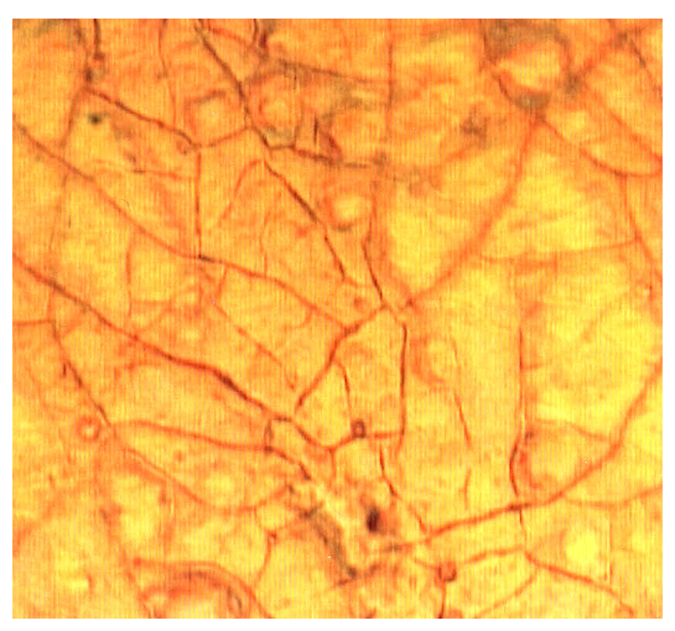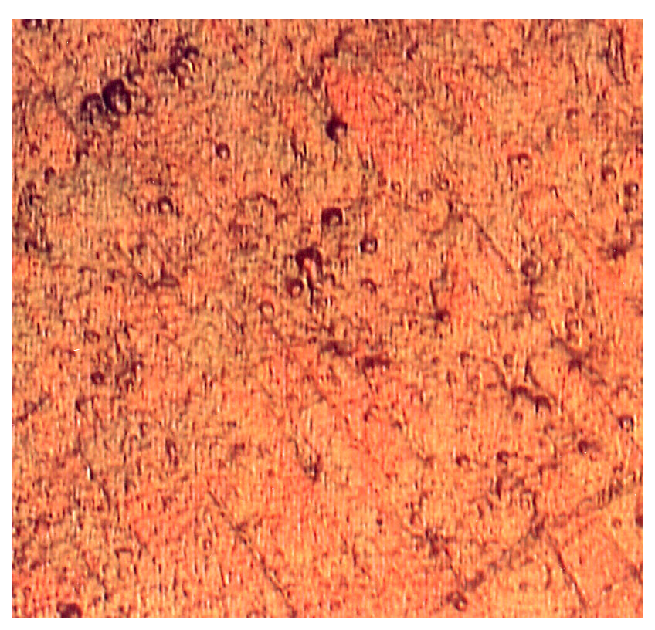

Picture 1: a) Micrograph of the surface of specimen 2 (Enlargment of 1000 x 200); b) Micrograph of the surface
of specimen 4 (Enlargment of 1000 x 200)

In picture b) we can see only pores. On the coating of Cr (III), pores are bigger and somewhat more unevenly distributed. On the coating of Cr (VI), pores are smaller and denser. Picture 2 shows the specimen in the cross section. We can see the thickness of the coating and of the base material.

Regular coatings have pores, cracks or limited permeability for chemical parts like ions and molecules. Because of all the listed factors it is no question when the corrosion will occur. It occurs right after the coating is exposed to the humidity in the air. The main question is how fast corrosion is in its initial state and how its speed increases with time. The longevity of the coatings depends on the kinetics of corrosion.
For coatings made of zinc or its alloys which are coated with chromium film, corrosion begins at pores and cracks of the chromium film. There is no essential difference between the layers which have and those which don’t have an additional protective layer.

In both cases, the only difference is in the number, size and depth of pores. At the beginning, the speed of corrosion depends on the size of the Zn surface which is exposed to the aggressive atmosphere at the bottom of pores (cracks). Smaller the size of pores and smaller their surface density, the smaller amount of zinc is transforming into the solution. Inside the narrow pores there is ZnO forming. During the oxidation, there is a layer being formed. This layer is preventing the access of oxygen and water to get to the surface of metal and thus the process of corrosion is hindered. Although this doesn’t prevent further corrosion, it does slow down the process.

We measured the thickness of each layer in the cross section. The measurements are given in table 2. We prepared four different specimens (table 2) for the experiment and we measured the thickness of layers at the enlargement of 1000. Micrograph of the specimen can be visible in picture 2 at the enlargement of 200 in the cross section.

Specimen number | Schematic cross section of the protective layers | Thickness of the protective layers (μm)
1 | Steel base  Zn coating  Cr (VI) layer  Steel base  Zn coating  Varnish  Cr (III) layer  Steel base  Zn coating  Steel base  Zn coating  Cr (III) layer  Cr (VI) layer  Varnish | 13
2 |  | 15
3 |  | 7
4 |  | 12
Table 2: Measurements of the thickness of layers

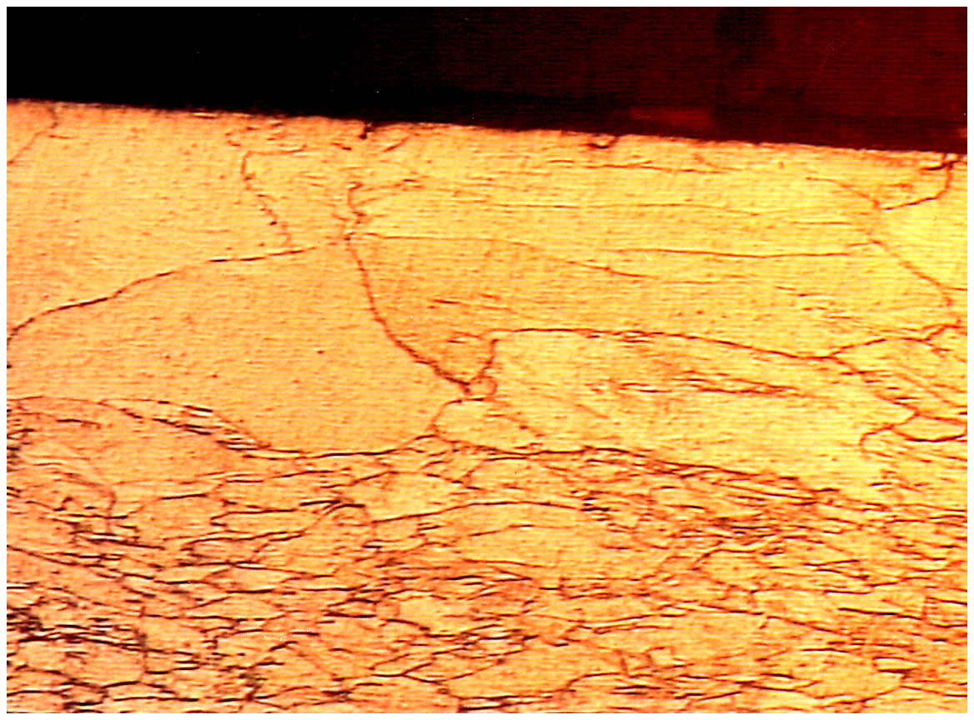
Protective layer
Steel base

Picture 2: Micrograph of the specimen in the cross section, enlargement of 200x

It is evident from picture 3 that the thickness of the covering layer from the yellow passivator, which contains Cr (VI) is larger than the layer of the blue passivator, which contains Cr (III).

(μm)
Covering layer of Cr (VI)
Covering layer of Cr (III)

Picture 3: Thickness of the covering layers

- RESULTS OF THE MEASUREMENTS IN THE SALTY CHAMBER

For fast detection of the irregularities on the protective coatings, we carried out a test in the salty spraying fog. Corrosion load in these tests is different from the possible load in life where corrosion can take place under other conditions. The aims of this experiment were to test metals, metal and non-metal inorganic coatings on metals as well as to research the systems of coatings [7, 8].
Based on the obtained results we decided to test the specimens in the salty chamber. Experiments were carried out by the standardized procedure DIN 50021 SS. We tested specimens 2 and 4. These are two different specimens which have different covering coating. Sample 2 is a specimen covered with a layer of zinc, Cr (VI) passivator and varnish. Sample 4 contains a layer of zinc, Cr (III) passivator and varnish. Picture 4 shows the two specimens.

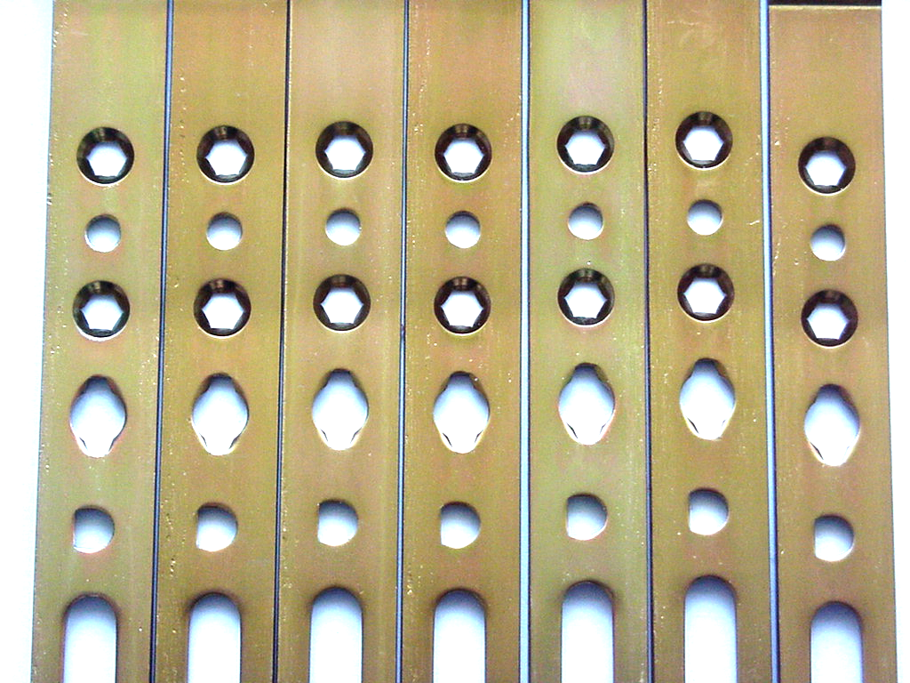
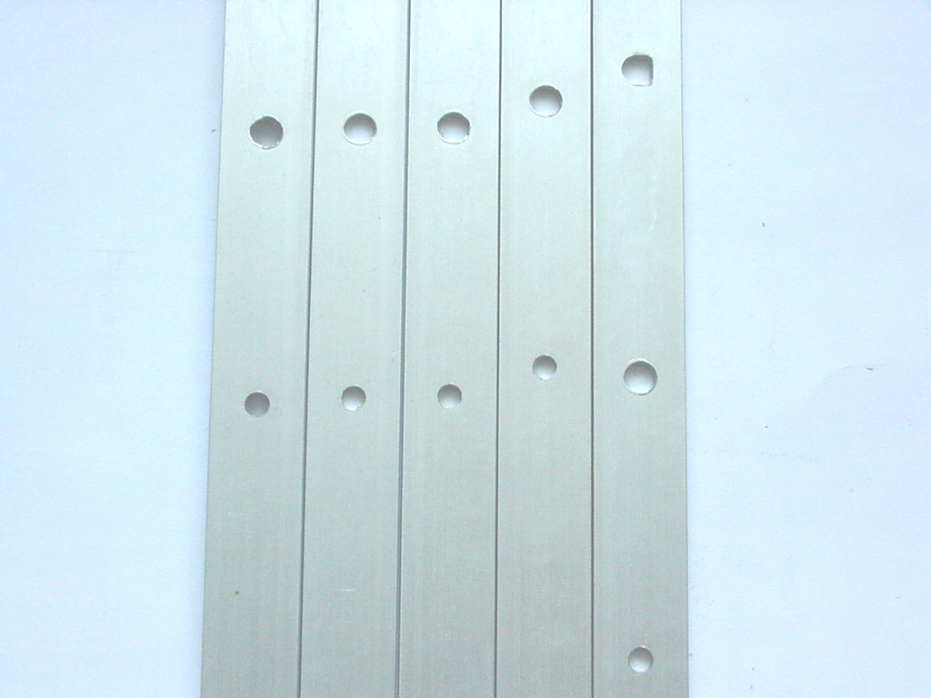
a)
b)

Picture 4: a) Specimen covered with a yellow passivator (chromium VI); b) Specimen covered with a blue passivator
(chromium III)

We put the specimens in a special device where we carried out the tests by the standardized procedure. Before exposing the specimens to the salty fog we let the specimens sit for 24 hours to ensure the stabilization of the surface protection. We used a spraying water solution NaCl, which caused damage of the protective layer. We accomplished the spraying of the corrosive medium with the help of the pressed air. Temperature during the experiment was 35 °C, and the pH value was 6,9. The specimens were exposed to the corrosive medium for 400 hours. Then we visually estimated their appearance. We took note of the white corrosion on the specimens.

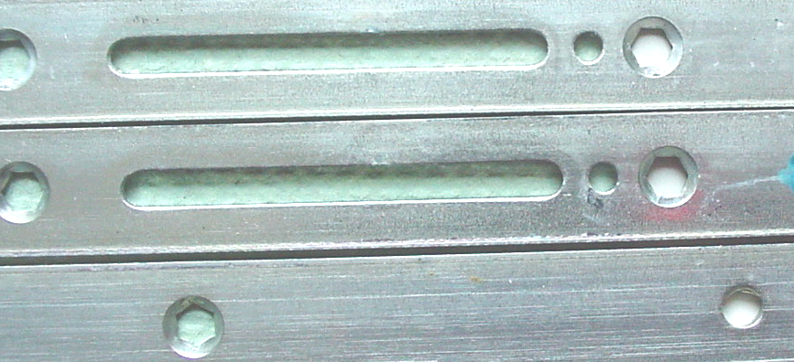

White corrosion

Picture 5: Occurance of white corrosion on the coating from the blue passivator
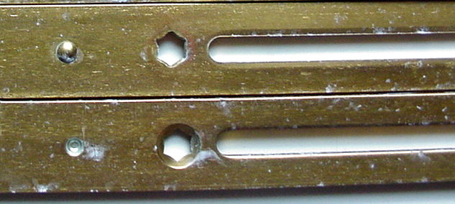
White
corrosion

Picture 6: Occurance of white corrosion on the coating from the yellow passivator
Based on the corrosion tests we came to the conclusion that white corrosion (picture 5 and 6) occurs after 400 hours in small amount as a very fine white haze. Corrosion doesn’t progress into the depth nor does it expand within 600 hours. After 600 hours we noticed progressive decaying of the coating and the process of corrosion begins on the base material and red corrosion occurs on the products made of steel. Picture 7 shows the durability of the coating in the salty chamber for the covering layer of chromium (VI) passivator – specimen 2 and chromium (III) passivator – specimen 4.

Required durability of protective layer
Covering layer of chromium Cr (VI)
Covering layer of chromium Cr (III)

Picture 7: Comparison of the actual and required values of the durability of the specimens in the salty chamber

It is evident from the graph that we exceeded the required values of the resistance to the white corrosion for the specimens, which had chromium III passivator in their covering layer. We achieved that by applying an additional wax varnish on the specimen, which increased the resistance against corrosion from what was required at the beginning. We proved that the protective layer with blue passivation is equal to the yellow passivation.

- CONCLUSION

Corrosion is one of the main destroyers of human goods. Thus the tendency is to continue improving corrosion resistance. To improve the corrosion resistance of a particular product along with other suitable materials which are applied as protective coatings on the metal products was the main subject of our project work. Corrosive protective layer which we used on our specimens contained galvanized steel sheet as well as the covering layer of chromium (VI) passivator and varnish. Before applying the zinc we thoroughly cleaned the products. Cleaning the surface of the specimens plays an important part before the process of galvanization because it helps towards corrosion resistance. Surfaces which are not cleaned are not compact and the coat of zinc is uneven.On top of the galvanized layer, a covering layer of chromium (VI) is applied. The application of this coating has shown itself to be damaging to the environment because the waste of the materials used in this procedure can’t be disposed at the waste deposit.
Accordingly we changed the old way of protection and carried out a different method. This was achieved by changing the passivator. We introduced a chromium (III) passivator. To ensure a successful application of the new layer it was necessary to change the application technology as well as the method of varnishing. The measurements of the durability of the specimens in the salty chamber showed that it is possible to achieve same results with a suitable varnish and Cr (III) coating as well as with coatings which contain Cr (VI).The technology and usage of chemical substances in the case of using the Cr (III) passivator is more expensive. But this is justifiable when we consider that the most expensive technology is environmentally contentious. Based on the analysis of the waste material, which occurs as by product of technology, the amount of waste (sludge) decreased in the ratio of 2 : 1 to the benefit of the technology based on chromium (III).

- LITERATURE

- Galvanotechnik, (2004).: št.2, 3.
- Čretnik, D. (1999).: Tehnologija spajanja in preoblikovanja. Tehniška založba Slovenije ,Ljubljana.
- Tonkovič, M. (2003): Gradiva, Šolski center Novo mesto.
- Ecghart, I(1994).: Kemijska tehnika : Založba Jutro.
- Interni standardi površinskih zaščit.(2003): Kovinoplastika Lož,.
- Jelinek, T.W. ( 2002)..: Galvanische Verzinkung, Schritenreihe Galvanotechnik.
- Standard ISO 9227: Corrosion test in arificial atmosphers – salt spray test. DIN EN 12329 Korosionschutz von Metallen.

